2016 Annual Report
Community Services Department

Comprised of Recreation and Parks, Council on Aging, Veteran’s Services, Human Services and the Natick Community Organic Farm, the Community Services Department is charged with responding to the needs, interests and quality of life issues for all who call Natick home. Together we seek to elicit the priority needs and interests of residents and respond to those priorities through well conceived program development, efficient service delivery and thoughtful trusteeship of the array of public facilities and resources under our purview.

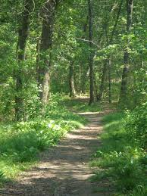
2016 Stats At A Glance:
- Master Plan for Parks and Fields completed
- 10,000 + Natick residents registered in one or more department program/service
- 1,100 Volunteers contributing 51,000 hours of service
- 987 passengers used our enhanced transportation service
- 384 Natick residents received Case Management/Information and Referral services
- $276,000 in direct Veteran benefits obtained

Thousands of residents of all ages and abilities benefitted from hundreds of classes, workshops, summer camps, clubs, special events, advocacy and supportive services offered by the dedicated and professional staffs that comprise the department.

Citizens Leadership Academy
In an effort to increase citizen understanding of municipal operations, the Department continued to manage the Town of Natick’s Citizens Leadership Academy. A collaborative effort involving all town departments, the 10 week program is designed to advance understanding of and participation in civic affairs as well as to increase awareness of the challenges facing municipal government. Extremely well received, the Academy has graduated 100+ Natick residents who can now distinguish themselves as citizen leaders.

Public Spaces
The Department is pleased to oversee many of the Town’s most treasured public spaces from our many parks to the town common; the town beach to our organic farm.

This past year department staff successfully completed a Master Plan for Parks and Fields and is currently in the design phase for both the East School and Navy Yard parks.

With the help and support of many town departments, we help to ensure that many of Natick’s most popular public events run smoothly including: Natick Days, Concerts on the Common, Family Movie Night, Natick’s Farmer’s Market, our many Veteran’s dedications and parades, and various holiday celebrations in partnership with many dedicated community organizations and individuals.

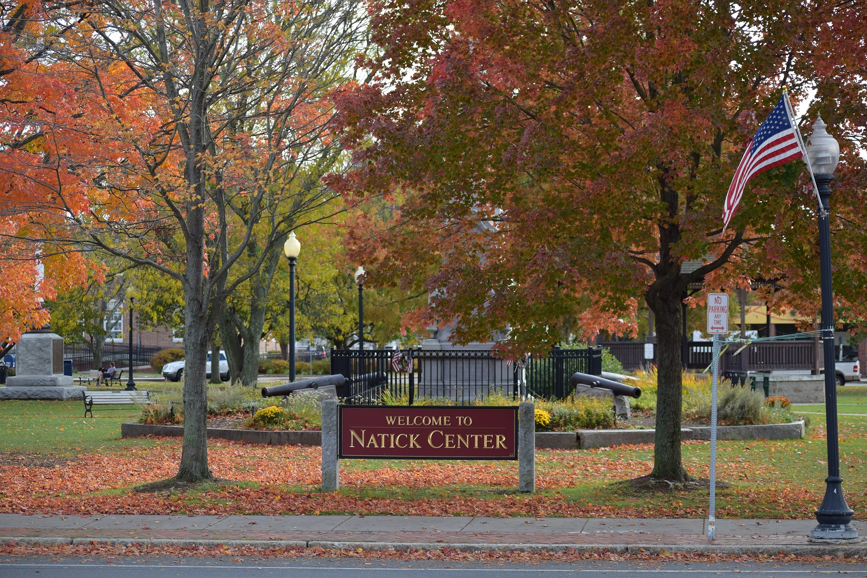

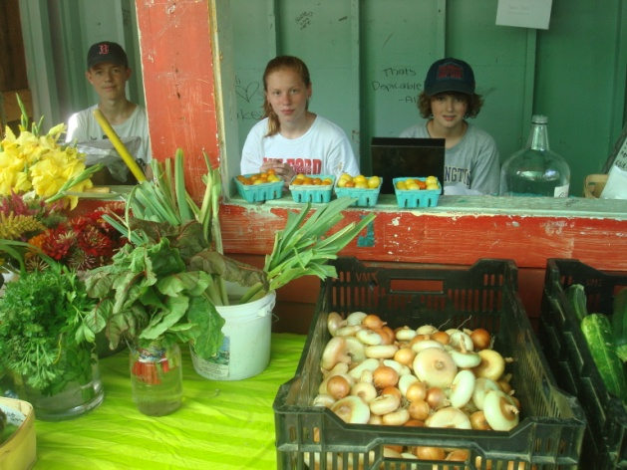

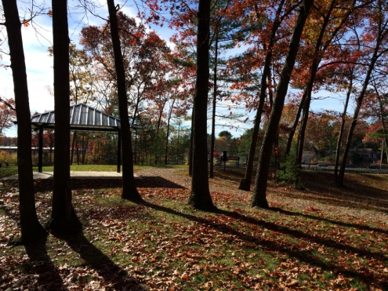

Local Transportation
The department’s enhanced transportation program expanded in 2016: adding a second passenger van as well as an electric car. In 2016:
- 987 passengers took advantage of our services
- The majority of riders were transported to medical appointments
- We logged over14,000 miles
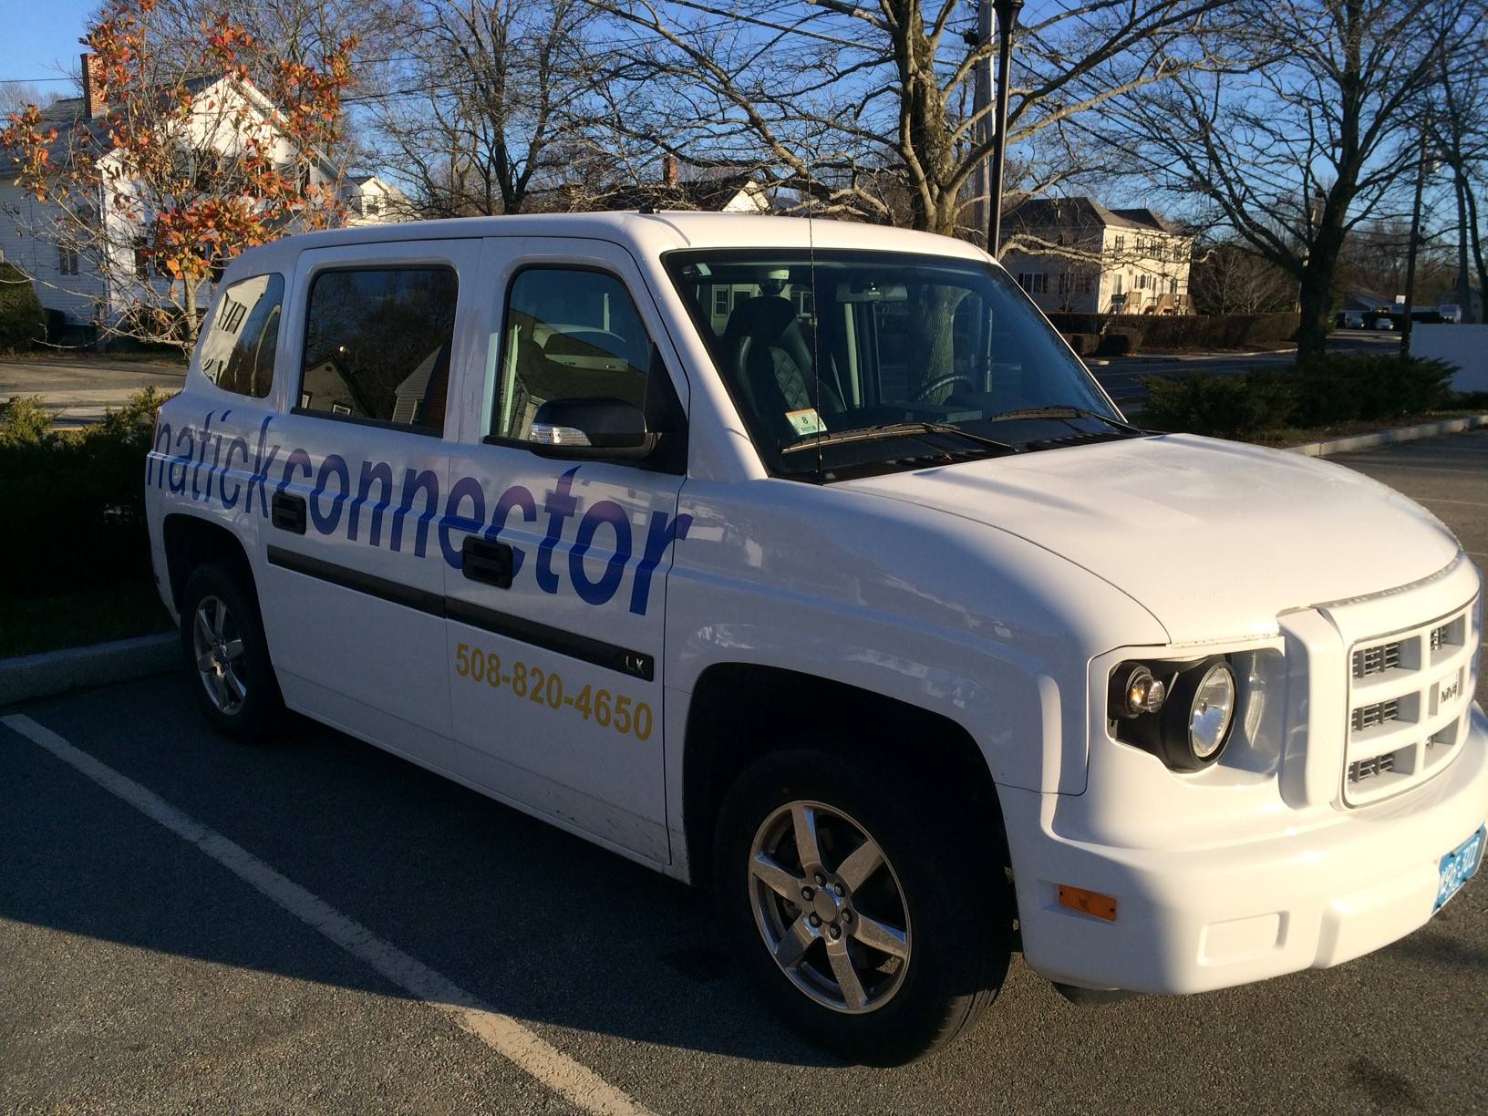

The department is extremely fortunate to work with some 1,100 volunteers across our divisions who, together, provided in excess of 51,000 hours of service to our community. Whether serving as mentors, teachers, coaches, drivers, friendly visitors, camp assistants, farmers, board and commission members, friends, crafters or advocates, each individual helped to ensure our vast array of programs reached as many residents as possible

The Department plays a vitally important role in Natick; to help strengthen the fabric of the community through partnerships, collaborations, communication and service delivery. The dedicated professionals that comprise this department work hard every day to ensure our services are on target, accessible and of high quality. I consider it an honor to work with this remarkable team.

Respectfully submitted,

Jemma Lambert, Director
Community Services Department

Council on Aging Division

Our center strives to create an environment which values diversity, mutual respect, and supports inclusive ways to work to provide support services, programs and advocacy for people of all ages and abilities.

The mission of the Natick Council on Aging is to design and deliver services which improve the quality of life for those aging in our community through education, advocacy, and support.

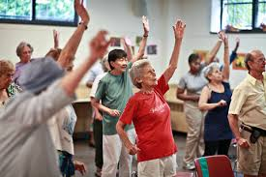

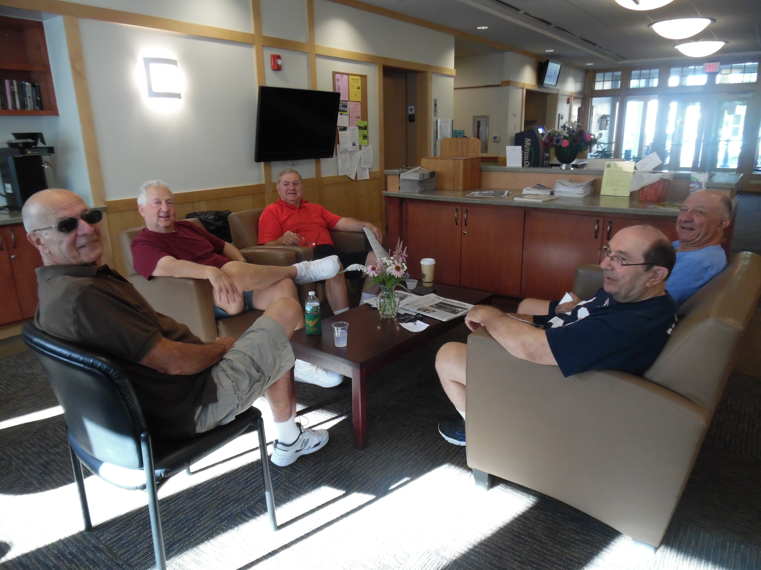

2016 Stats–At-A-Glance:
- Nearly 40% of Natick residents 60 years of age or older benefitted from one or more Council on Aging programs
- Arts & education programs expanded with the introduction of video conferencing and live streaming in addition to a Cultural Council Grant and book club with Bacon Free Library

- Enhanced local transportation with the acquisition of an electric car to meet medical transportation needs
- Launched Community Pass (CP). CP allows residents to register for programs and remit payments on line.
- Began local museum trips via the Natick Connector
- Held focus groups with the LGBT community
- Strategic planning services secured with SOAR 55 Consulting Group
- Collaborated with the Human Services Division to offer a series to help determine ones best option for aging in place, Bulky Waste pick up for isolated seniors & Natick Lights Up the Holidays program.
- Expanded dining options at the center

Volunteers:
- 669 volunteers provided 12,297 hours of service
- Introduced Better Impact volunteer software program allowing volunteers to obtain information and/or register for assignments and log in their hours on-line.
- 24 Meals on Wheels drivers delivered over 15,000 meals
- Trained volunteers to provide Registry of Motor Vehicle transactions (RMV Near Me)

Community Partners:
The following groups, Friends of the Natick Senior Center, BayPath Elder Services, MetroWest YMCA, Olin College, Mass Association of Councils on Aging, LGBT Aging Project at the Fenway Institute, Dana Farber Mammography Program, Mary Ann Morse Health Care, Whitney Place Assisted Living Residences, Needham Bank, MetroWest Chamber of Commerce, INTERFACE referral service at William James College, MA Registry of Motor Vehicles, Eliot HealthCare, and many local business owners, medical professionals and residents supported the Council on Aging with their financial and professional expertise during 2016.

On behalf of the Council on Aging staff and volunteers best wishes for a happy and health New Year.

Respectfully submitted,
Susan Ramsey
Director, Council on Aging

Human Services Division
The mission of the Human Services Division is to provide a safety net for Natick residents of all ages through the provision of information and referral, supportive case management, and by actively working to strengthen interrelationships among area service providers.



Specific services provided include:
- Information and Referral
- Needs assessment
- Case management:
Advocacy
Crisis intervention
Public and private benefits
Assist with applications
Identify resources
Make referrals

2016 Stats At A Glance:
- 384 Individuals received case management/I&R services
- 101 individuals received $58,485 in home heating assistance
- 14 households received food stamps
- 5 Protective Service reports filed
- 108 residents enrolled in the Care and Prepare emergency response program
- Facilitated support groups in the areas of Bereavement and Hoarding assisted some 22 individuals with information and support
- In collaboration with the Department of Public Works Natick Human Services facilitated a free bulky waste pick-up day for low income elders. 52 residents participated.

Collaboration
The Human Services Division works hard to ensure that the network of local services providers /responders both communicate and collaborate effectively. To that end Natick’s Support Team is hosted and facilitated by Human Service staff. This past year the Team focused their professional development in the following areas:
- Psychiatric Emergency Services
- Protective Services and Scams
- Behavioral Health
- Safe Driving Best Practices
The Human Services Team could not do what they do without the help and support of our emergency responders, Health Department, Inspectional Services team, Department of Public Works, as well as the Community Services Team in general. We’re most appreciative of the strong and collegial relationships in and among these municipal entities.

Teri Checket MS LSW
Social Work Coordinator

Recreation & Parks

The Natick Recreation & Parks Division is responsible for the planning, organization and implementation of recreational programs for residents of all ages and abilities and, as well, to serve as stewards of Natick’s open spaces, parks and fields.

Early in the year the division completed its Master Plan for Parks and Fields; a major project that will serve Natick’s residents long into the future by providing a logic model for capital improvement of our outdoor resources. As a direct result of that Master Plan we have initiated the design phase for both the East School and Navy Yard parks.

This past summer we experienced a great loss at Camp Arrowhead when the main building on the site was destroyed by a fire. With the support of the Departments of Fire, Police, Public Works, Community Services, and the assistance of all Natick Veteran’s groups, Town Administration and Facility Maintenance, we were able to finish out Camp Arrowhead’s 2016 summer season on-site with creative, temporary accommodations. We hope to rebuild the main facility in the summer of 2017.

2016 At-A-Glance

Class | FY 13 | FY 14 | FY 15 | FY 16
Adult | 73 | 50 | 51 | 54
Preschool | 64 | 62 | 81 | 78
Special Needs | 58 | 83 | 82 | 94
Youth | 164 | 167 | 157 | 178
Total Offerings | 359 | 362 | 371 | 404

We are fortunate to benefit from the contributions provided to us by many wonderful volunteers throughout the year. We have individuals coaching, building sets, cleaning parks, helping 1:1, and so much more. In all we had 734 volunteers provide 26,649 hours of service. Equated to the average part time salary in our division that is close to $403,220 in salaries saved through volunteer service.

We want to thank our fellow departments for their efforts throughout the year; Public Works, Police, Fire, Facilities Maintenance, Community Development, Board of Health, Human Resources, Finance and the School Department all allow us to provide the level of service to the residents of Natick.

Jess Ordway, Chair
Dan Keefe, Acting Director of Recreation & Parks
Members, Mike Fair – Vice Chair, Richard Cugini, Richard LeBlanc, Seth Levine, David Ordway, Sue Shea,
Wayne Szretter, and Greg Tutuny

Veterans’ Services

Veterans’ Services is responsible for addressing the unmet needs of Natick Veterans and their dependents. Through our advocacy we help to ensure that our Service Men and Women access the support, benefits and services they need.

A central role this office plays is to assist our Veterans with filing for and receiving state and/or federal benefits due them. Our efforts result in the acquisition of cash and/or medical awards which in the case of the state, are reimbursed in a cost-sharing agreement with the Town in which the state pays 75% and the town 25%. Without this important partnership the Town of Natick would be obligated to cover 100% of those costs.

The following outlines a three year history with regard to the acquisition of Chapter 115 (state funds) on behalf of Natick Veterans and their dependents:

Year Medical Cash
2014 $129,539.00 $100,747.00
2015 $124,945.00 $113,800.00
2016 $145,685.00 $129,591.00

This office also processes VA claims directly with the VA. The first 3 years finishing in 2014 brought lifetime awards totaling $2,092,168.020. The years 2014 and 2015 brought in awards totaling $2,018,381.00. For the past year 2016 we saw awards totaling $1,425,000.00. There were 125 new claims and 57 awards in the year 2016.
This is the first year that this Division has gone through a 3 year certification process. We are pleased that our office passed both exams.

Our office provides a range of additional services to Veterans and dependents including the following:
- Medical Referrals
- Educational benefits
- Assistance with job search/unemployment benefits
- Emergency funds
- Counseling
- Assistance with applications and additional benefits programs
- Military records

In addition this office attends to the following:
- Serve as the Burial Officer to help indigent veterans and their dependents.
- Serve as the Grave Registration Officer to ensure that all graves of Veterans are properly decorated with a flag and geranium over the Memorial Day period.
- Conduct parades and ceremonies.

In 2016 the Veterans Services Division initiated an educational campaign regarding Veteran suicide. Working in collaboration with sister offices across the Commonwealth we hope to raise awareness about the 22 Veterans a day who take their own lives across this country.

This office works collaboratively with many Town departments, most notably with the Council on Aging and Human Services Divisions as well as with numerous local and state organizations including: Natick Veterans Council, Mass Bay Community College, MA Department of Veteran Services, Women Veterans Specialist, SHINE, Veterans Inc. Resources, Veterans Service Officer Association of MA, Northeast Service Officers Association.

We are looking forward to a great 2017 year and are appreciative of your continued support.

Paul E. Carew
Director of Veteran Services / Natick Community Services Department

Natick Community Organic Farm

The Natick Community Organic Farm (NCOF) and the Town of Natick enjoy a truly unique partnership; utilizing conservation lands held by the Town of Natick, NCOF provides local organic food, hands-on learning, and trusteeship of open space for all who call Natick home. A private nonprofit, NCOF, Inc. is a certified-organic farm providing productive open space, farm products, & experiential education for all ages, year-round.

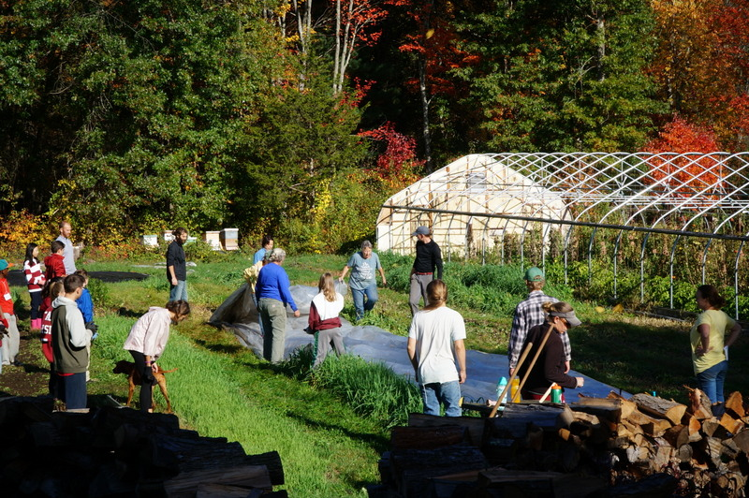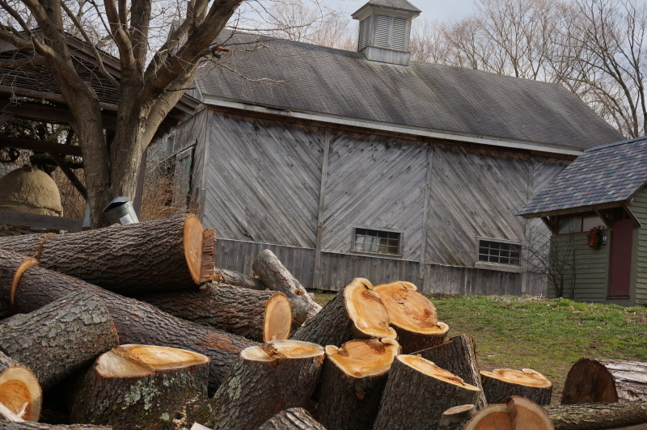

Year-At-A-Glance
- Produced 164 gallons of maple syrup during an extremely short sugaring season of 23 days.
- Persevered through a severe drought.
- Built Good Agricultural Practices (GAP)-compliant washing station for processing produce.
- Planted a new raspberry patch.
- Produced 40,000 organic seedlings including 1,500 for Fenway Park’s rooftop garden.
- Provided thousands of customers and 60 CSA shareholders with over 15,000 pounds of fresh, local certified-organic vegetable, 40,000 flowers and over 4,500 pounds of humanely raised meats.
- Hired our first Farmers’ Market Manager.
- Purchased a refrigerated delivery truck and a dump attachment for the Farm truck.

Education & Volunteering
- Sheared sheep in front of 460 students including all of Natick Public School’s first graders.
- Revamped Girl Scout badge programs.
- Expanded Mentoring Teens through Agriculture Apprentice program from two to 12.
- Hosted 8th grade students from Kennedy Middle school for their fall project and Natick High School seniors completing community service.
- Piloted Friday morning Forest Gnome program.
- Introduced “Baby and me” programming for parents and their one- to two-year-olds.
- Taught 591 kids ages three-to 14 in summer programs.
- Educated over 2,700 students through School Programs.
Events & Fundraising
- Increased membership by 12%.
- Hosted a record number of guests at Maple Magic in March and a sold out Harvest Dinner in September.
- Held the barnyard premiere of video documentary maker Kori Feener’s 12-part serial documentary about NCOF called “On the Farm.”
- Launched public phase of Capital Campaign
- Talked about turkeys on NPR’s All Things Considered.

Respectfully submitted,

Lynda Simkins
Director, Natick Community Organic Farm

